#### Student Activity 1

Before you can complete any of the activities in this course you will need an SQL environment. The most easily accessible and portable MySQL environment is XAMPP. This software can be downloaded from <https://www.apachefriends.org/index.html>. It is free of charge under the terms of the GNU General Public Licence. The installation and setup is well documented in the Frequently Asked Questions

FAQ : <https://www.apachefriends.org/faq_windows.html>

Once you have the Control Panel open with both the Apache and MySQL modules running you will be able to open the web interface.

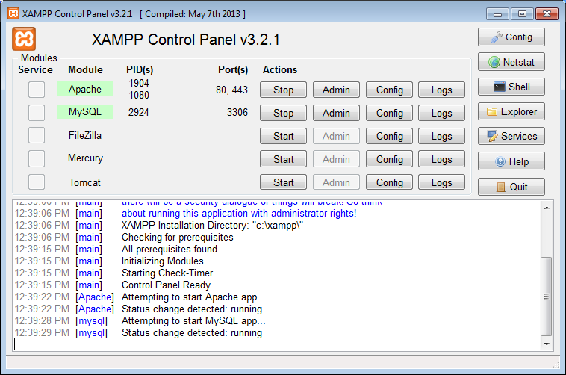

It is preferable to use a NON-Internet Explorer based browser as some features of the web interface are not supported by Microsoft. If you have a standard XAMPP setup you will be able to open any browser and type in the following address to access MySQL;

http://localhost/phpmyadmin/

**Step one:** create a new database called “hardware”. Refer figure 1.

**Step two:** open the database and then import the “products.sql” file. This file is in the resources folder associated with this course, or contact your lecturer for further details.

**Step Three:** open the products table and click Browse to see the details of all the records. Your table should have 617 records.

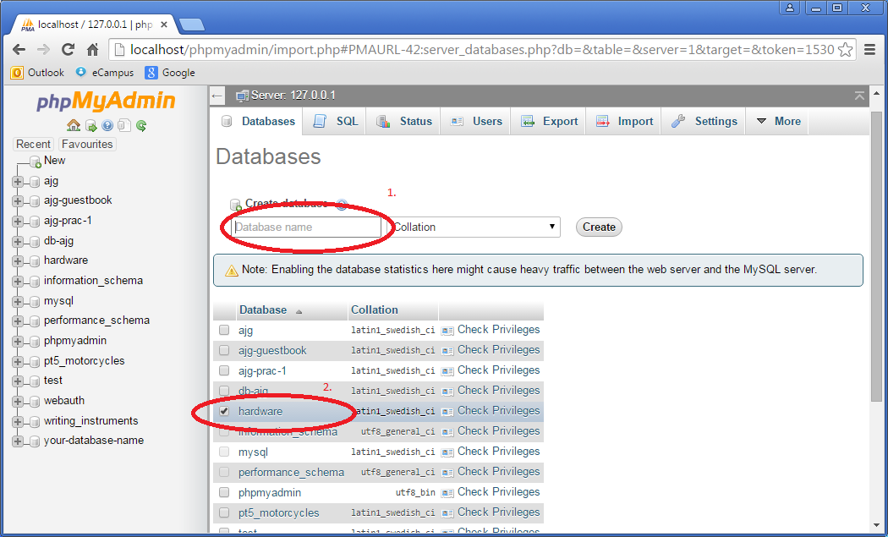

Figure

There are too many records to sift through to find a specific record, for example; How many items are made by Widget? This can be achieved by writing a query in the SQL pane/tab.

**Step Four:** Click on the SQL pane/tab and type in the following query (refer Figure 2):

SELECT * FROM `product` WHERE `supplier` = "Widget"

Or

SELECT * FROM product WHERE supplier = "Widget"

Note: The single quotes (grave accent symbol) may not work on some systems.

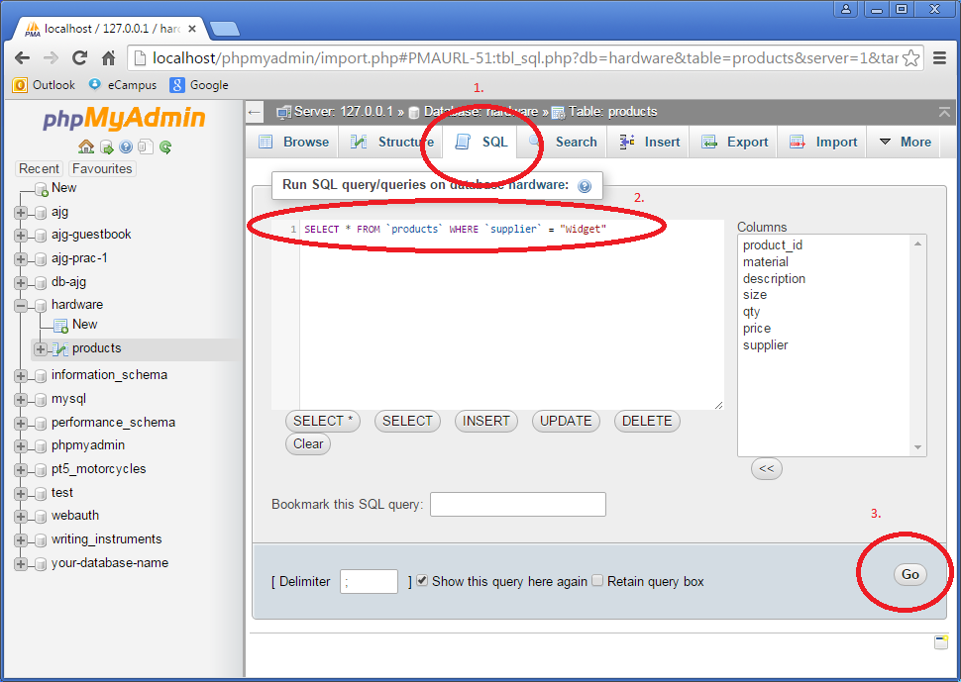

Figure

The results will be displayed as shown below. There are 29 items which are supplied by Widget. You can alter the Number of rows to be displayed so that all records appear on one page (refer Figure 3).

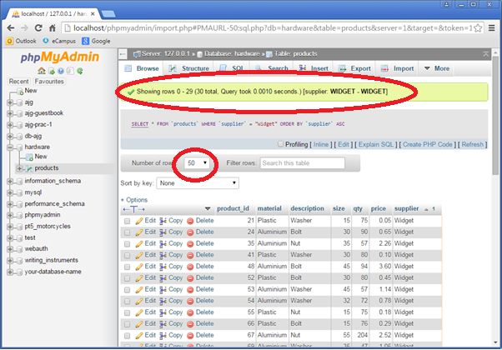

Figure

End of Student Activity 1